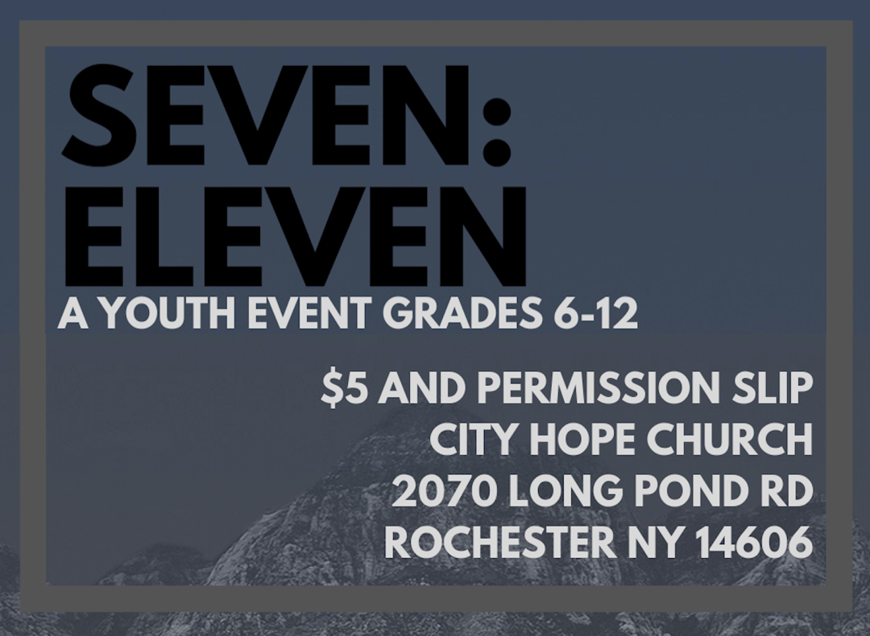
Please remove and turn in the “signed” bottom portion at the event
- - - - - - - - - - - - - - - - - - - - - - - - - - - - - - - - - - - - - - - - - - - - - - - - - - - - - - - - - - - - - - - - - - - -
RULES: RESPECT the building, the leaders and the other students

I, as the teen, understand and agree that if I violate these rules, my parents will be contacted and I will be sent home IMMEDIATELY.

WEBSITE CONCENT: Please check one of the following choices.
- I/We GRANT permission of my child(ren)’s photo /image to be published on The Church’s website/social media platform.
- I/We DO NOT GRANT permission of my child(ren)’s photo /image to be published on The Church’s website/social media platform.

ALLERGIES/MEDICATIONS: List any allergies or medications that would be needed during this event. Please designate the dosage also. The Youth Pastor/Leaders MUST be notified of any medications (prescription or over the counter) at arrival of event.
________________________________________________________________________________________________________________________________________________________________________

PARENT/GUARDIAN (Print Name)________________________________________________________
PARENT/GUARDIAN (Signature)_________________________________________________________
PARENT/GUARDIAN Emergency Contact Phone#____________________________________________
STUDENT (Print Name) _________________________________________________________________
STUDENT (Signature) __________________________________________________________________
DATE _______________ My student is free to leave at the end of the event
I will come in and pick up my student at the end of the event

